Maharishi University of Management
Event management system
Professor Shafqat Shad, MPP 2016
By Sujan Shrestha and Nishant Balami

Table of Contents
Introduction 2
Features 3
Tools and technologies used 4
Diagrams 5
Class Diagram 5
Use Case Diagram 6
Sequence Diagrams 7
Login 7
Add Personnel 8
Edit Personnel 9
Delete Personnel 10
Create event 11
Add Student to Event 12
Cancel Event 13
Generate Report 14
Object Diagram 15
UI screen shots 16
Possibilities for future enhancement 30

Introduction
Event Management System is a system that helps to keep records of past events as well as upcoming events of an organization/university. The system basically allows the managers to keep history of previous events, create new events, make necessary changes in them etc. The system is developed using Java and JavaFX technologies.
Event Management System is primarily developed for universities and it concerns with two different types of events, ‘On Campus Events’ and ‘Off Campus Events’. On campus events are the events that take place within the campus area whereas, off campus events take place in some different locations away from campus.
The system mainly focuses on four parties, the event, the managers, participants and resources needed for it. Managers are the ones who use the system. It allows them to add new managers, modify their records, keep track of resources, add new ones, keep history of students that have and have not been in previous events. The system also considers about managing transportation facilities, checking availabilities of vehicles, managing drivers, keeping records of miscellaneous expenses etc.
A proper tracking of past and upcoming events and proper management of resources are major features of Event Management System.

Features
Following are the list of features of the system:
- Create new events and make changes in upcoming events
- Create new managers and modify their records
- Keep records of students of different entries
- Add, delete and alter availability of resources
- Manage transportation facilities
- Track records of drivers, add and modify their records
- Keep records of miscellaneous expenses that happen during events
- View history of previous events and generate reports

Tools and technologies used
Following is the list of tools and technologies used in the development of the system:
- Java
- JavaFX
- JavaFX Scene builder
- Eclipse
- StarUML
- JSON data structure

Diagrams

Class Diagram
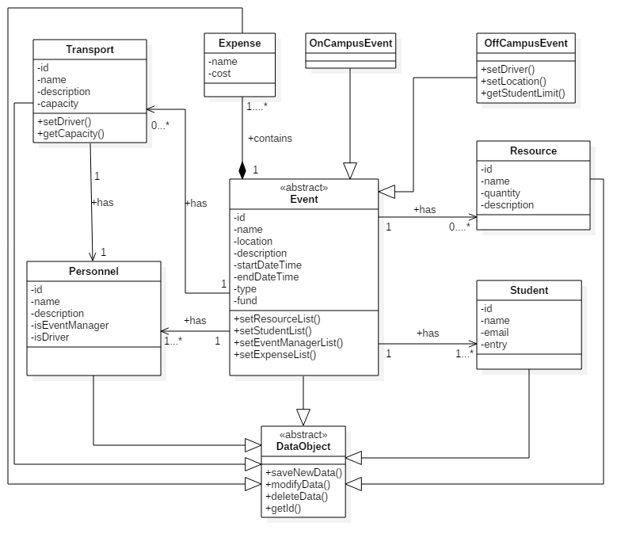

Figure: Class Diagram

Use Case Diagram

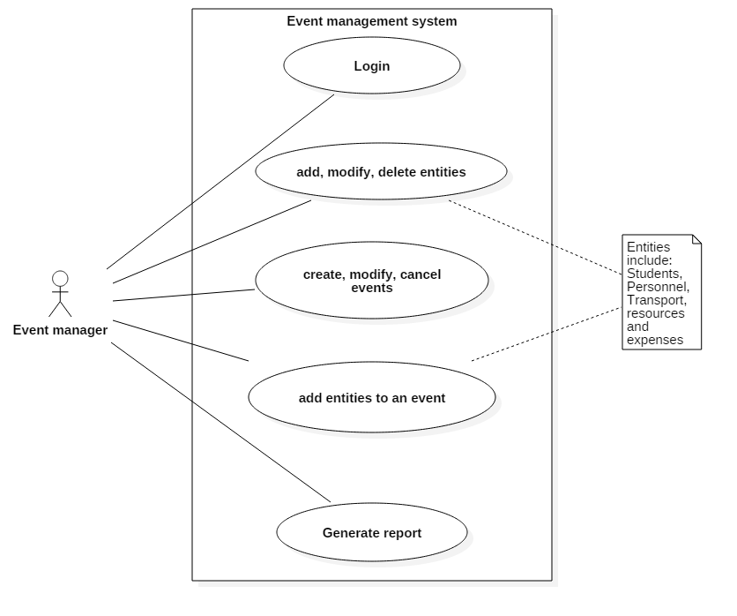
Figure: Use Case Diagram

Sequence Diagrams

Login
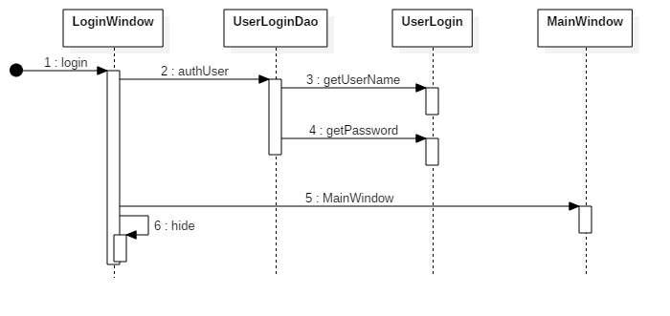

Figure: Login Sequence Diagram

Add Personnel

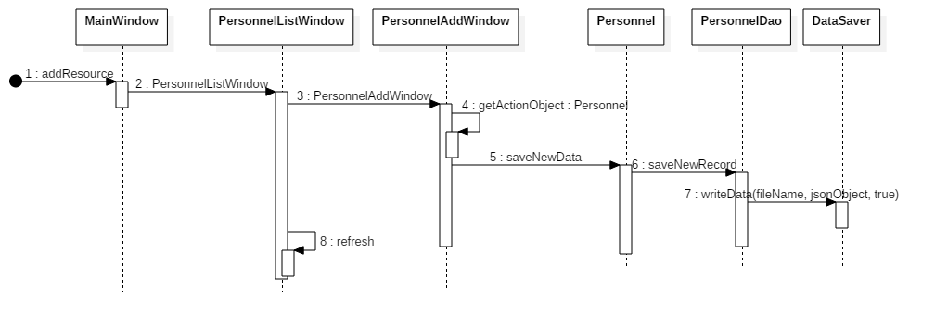

Figure: Add Personnel Sequence Diagram

Edit Personnel

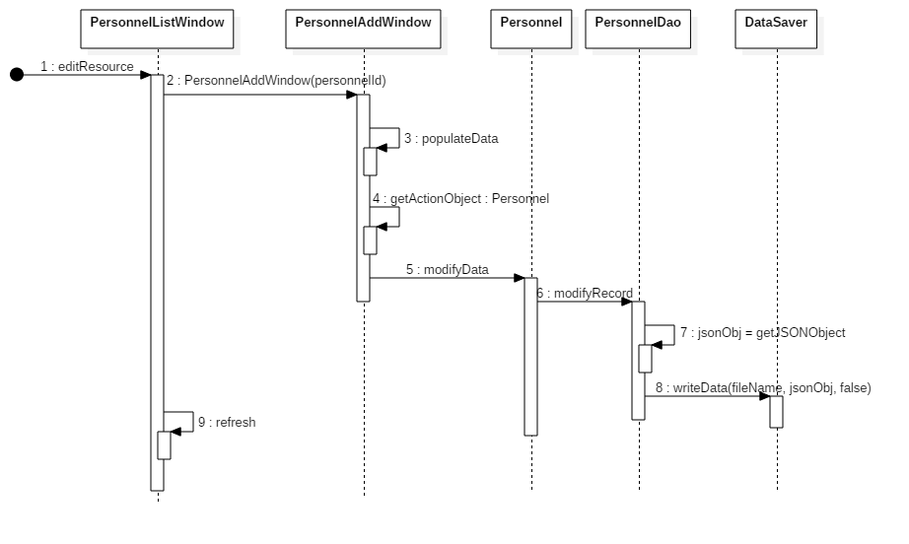
Figure: Edit Personnel Sequence Diagram

Delete Personnel
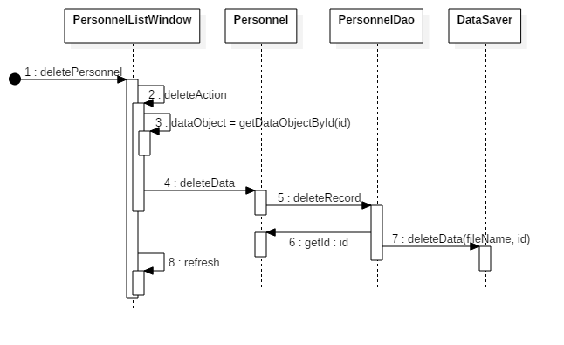
Figure: Delete Personnel Sequence Diagram

Create event
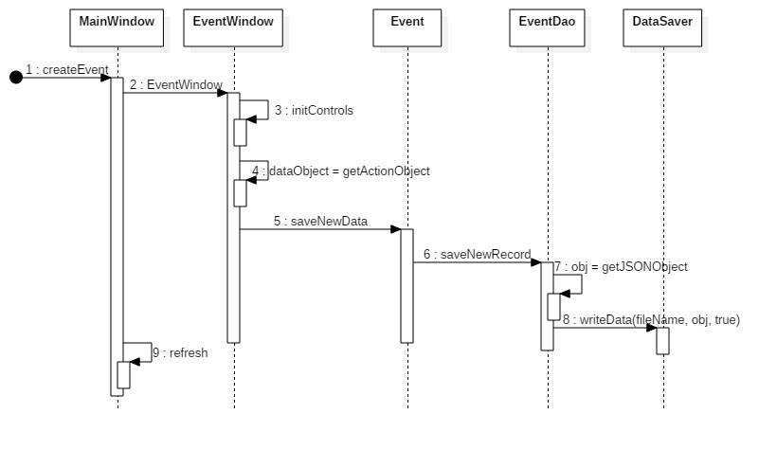
Figure: Create Event Sequence Diagram

Add Student to Event

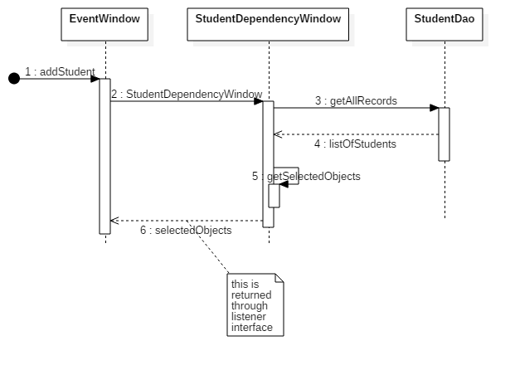
Figure: Add Student to Event Sequence Diagram

Cancel Event

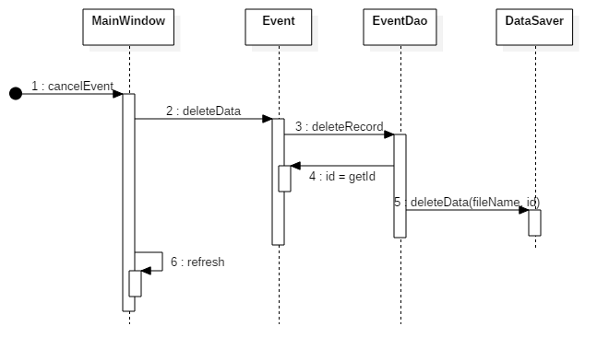
Figure: Cancel Event Sequence Diagram

Generate Report

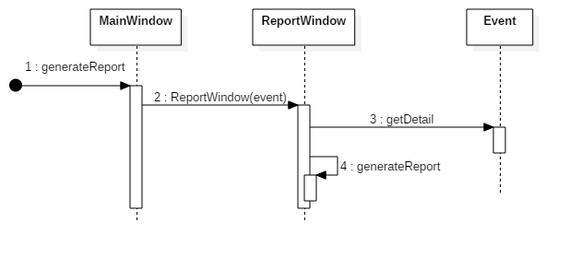

Figure: Generate Report Sequence Diagram

Object Diagram

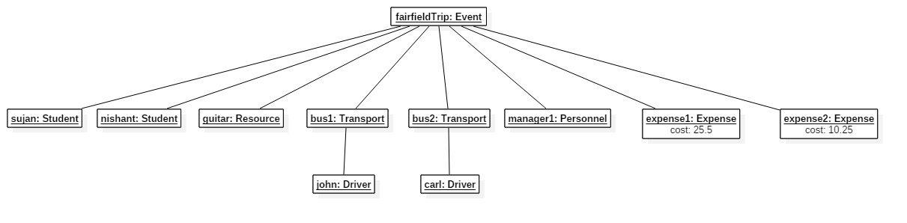
Figure: Object Diagram

UI screen shots
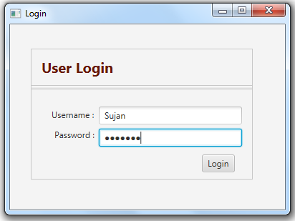

Figure: Login page

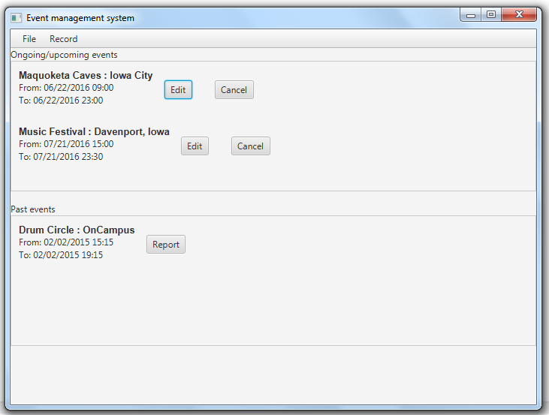

Figure: System dashboard

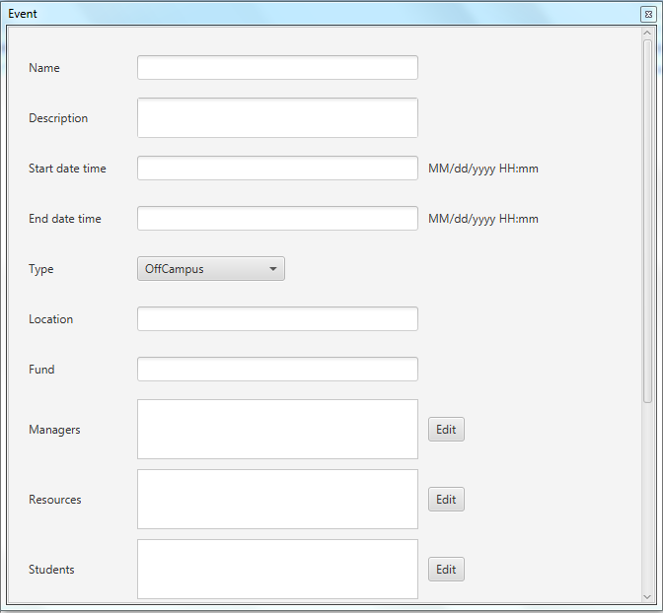

Figure: Create an event (I)

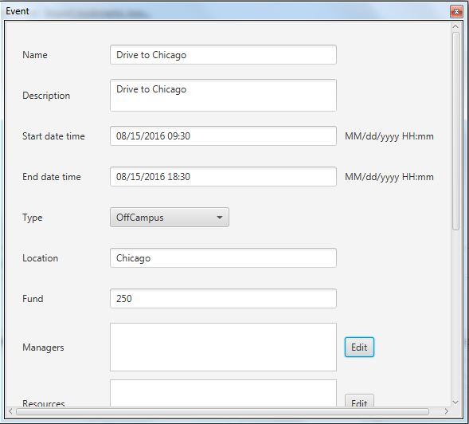

Figure: Create an event (I)

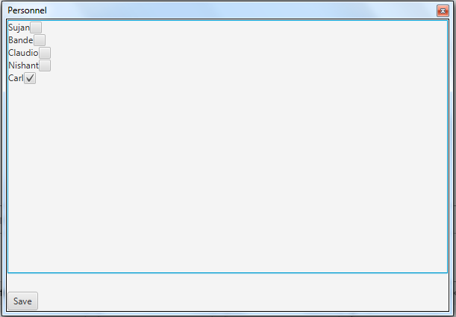

Figure: Personnel Selection

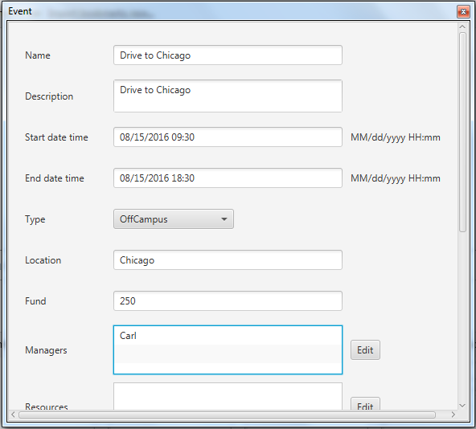
Figure: Selected Personnel
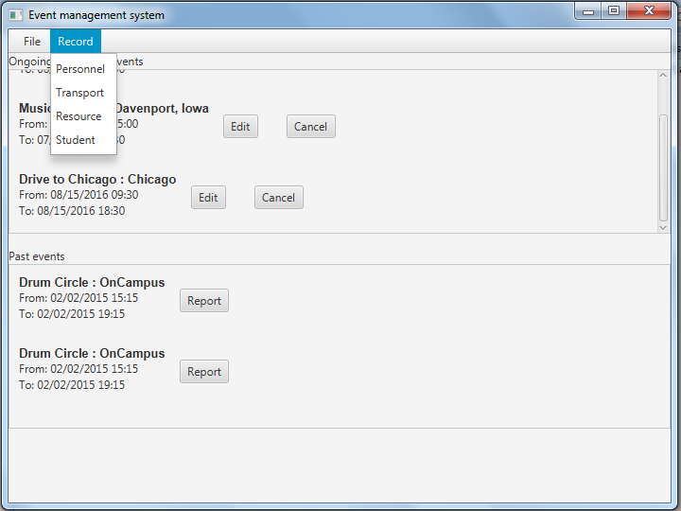
Figure: Entities of the system

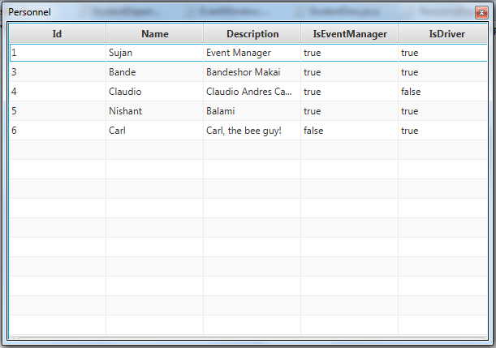

Figure: List of personnel
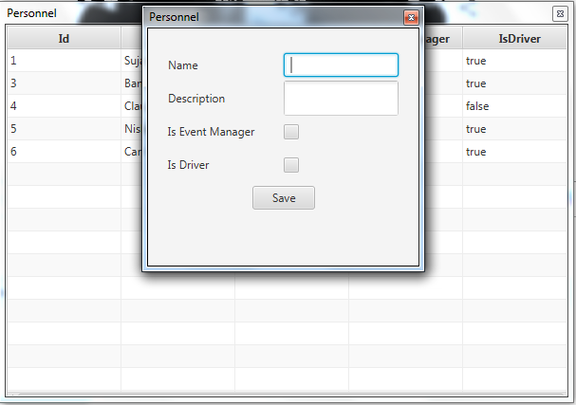

Figure: Add new personnel

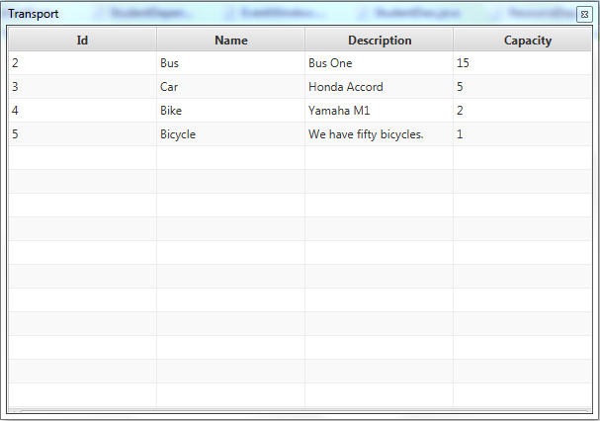
Figure: List of transports

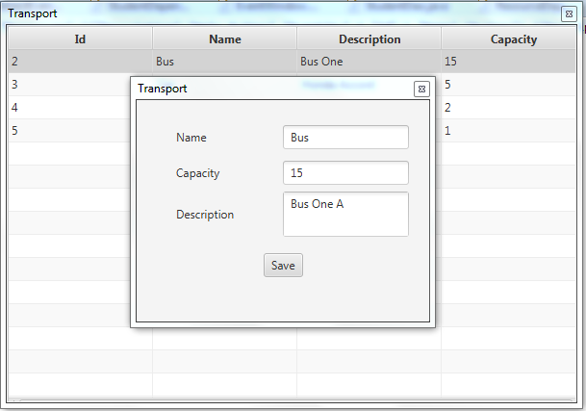

Figure: Edit data of transport (First Row)

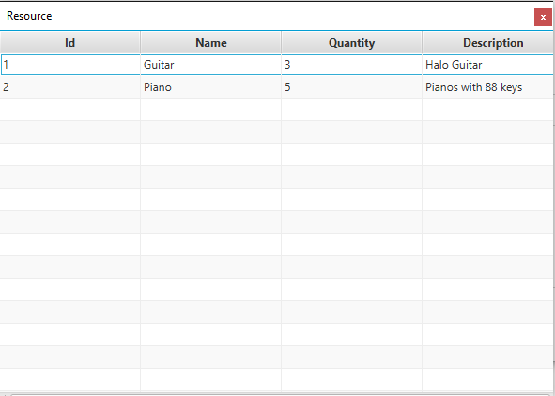

Figure: List of resources

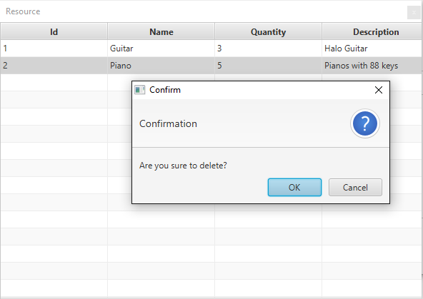

Figure: Delete data of resource

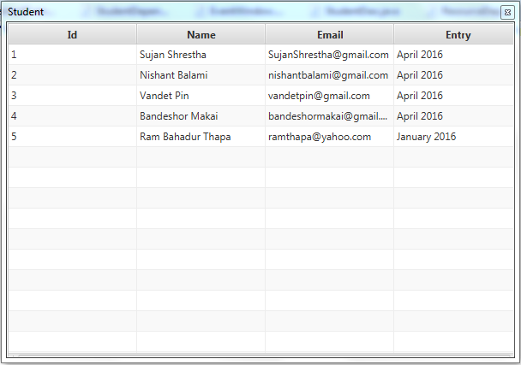

Figure: List of students

Possibilities for future enhancement
Because of the time constraints, there are lots of unfinished work. Following are the points for the future enhancement of the system:
- Improvement in the user interface.
- Currently, the system skips lots of validation in different form while saving data. This can be improved for the better usability of the system.
- The system stores all its data in flat file system, later it can be changed to proper relational database management system.

